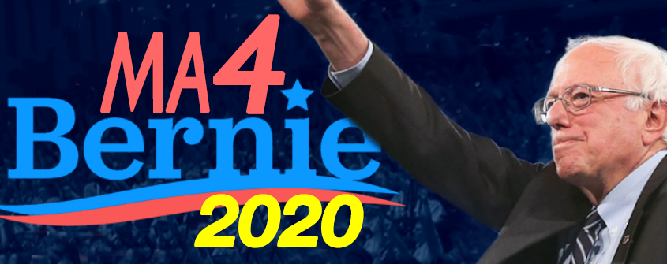
Contact: Jordan Weinstein
Phone: 617-290-1747
MA4Bernie2020@gmail.com
www.MA4Bernie2020.com

Press Release
For Immediate Release

Massachusetts Sanders Supporters Launch Statewide 2020 Campaign Network
Groups from the Berkshires to Cape Ann join forces in a move to put Bernie Sanders in the White House in 2020

Boston, Massachusetts, May 27, 2019. Supporters of Bernie Sanders’ 2020 presidential campaign have announced the formation of MA4Bernie2020, a growing statewide network of 14 local Sanders groups from across the state of Massachusetts, with a resource-rich website at www.MA4Bernie2020.com.

The seasoned activists who hail from Boston to the Berkshires are comprised of Bernie 2016 Democratic National Convention delegates, top organizers from the Massachusetts Sanders 2016 presidential campaign and other committed Sanders activists. Organizers describe themselves as an alliance of local groups throughout the Bay State mobilized in support of Senator Sanders' campaign to win the Democratic nomination and the Presidency in 2020.

“Bernie Sanders has the vision, moral courage and progressive agenda to be an FDR for the 21st century,” says MA4Bernie2020 co-founder Robin Bergman. “We believe he has the best chance of defeating Donald Trump and transforming America into the just, compassionate and prosperous nation we all deserve.”

According to Berkshires for Bernie co-leader Harley Keisch “Bernie has dedicated his entire life to working for social, racial, economic and environmental justice.” Keisch says he is convinced that “Sanders is committed to building a government and an economy that works for all of our citizens, not just those at the top.”

The primary in Massachusetts falls on a very congested “Super Tuesday” involving primaries and caucuses in over a dozen states. MA4Bernie2020 co-founder Lesley Phillips, who is also a member of the Massachusetts Democratic State Committee, points out that “It’s just a few days after the last of the ‘one at a time’ early primaries in February, so we believe that a unified action is necessary to help the Sanders’ campaign in our state, especially when it’s anticipated that the active candidate field will still be extremely crowded.”

Sanders’ supporters say they expect a major show of strength for their candidate at the upcoming Dorchester Day Parade on June 2, in Boston’s Dorchester neighborhood.

About MA4Bernie2020
MA4Bernie2020 (www.MA4Bernie2020.com) is an independent, all volunteer network of groups across Massachusetts working to amplify the national Bernie Sanders for President campaign, with the goal of winning the majority of the 2020 National Convention delegates in the Bay State’s March 3, 2020 Presidential Primary. Since its formation in April, 2019, MA4Bernie2020 has grown rapidly with organizers anticipating continued expansion as they network across the state. MA4Bernie2020’s 14 allied groups include: Arlington4Bernie2020, Cambridge4Bernie2020, Concord4Bernie2020, Lexington4Bernie2020, Newton4Bernie2020, SouthCoast4Bernie2020 and Waltham4Bernie2020, as well as ActonMA4Bernie, Berkshires for Bernie, Bernie Vision 20/20 Boston, Cape Ann for Bernie, Merrimack Valley 4 Bernie Sanders, MetroWest for Sanders 2020 and We Want Bernie-Worcester.

